Project Design Phase
Solution Architecture

Date | 17 February 2026
Team ID | LTVIP2026TMIDS66452
Project Name | ResolveNow: Your Platform for Online Complaints
Maximum Marks | 4 Marks

Solution Architecture:
Solution architecture for ResolveNow is a complex process that bridges the gap between public grievance challenges and modern technology solutions. Its goals are to:
- Find the best tech solution to solve existing business problems: Leverage the MERN stack to replace slow, manual complaint filing with a high-performance, real-time digital infrastructure.
- Describe the structure, characteristics, behavior, and other aspects of the software to project stakeholders: Illustrate how Socket.io provides live status behaviors and how MongoDB ensures secure, structured data storage for all logged grievances.
- Define features, development phases, and solution requirements: Outline critical phases such as JWT-based authentication setup, multimedia attachment integration, and the deployment of the admin resolution dashboard.
- Provide specifications according to which the solution is defined, managed, and delivered: Establish technical standards for real-time responsiveness, role-based access controls, and cloud scalability to ensure a reliable delivery for citizens and administrators.

Example - Solution Architecture Diagram:

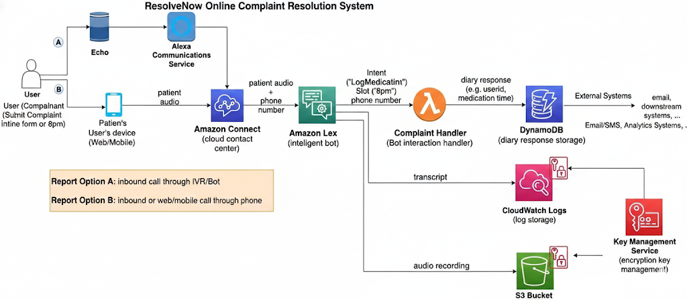
Figure 1: Architecture and data flow of the voice patient diary sample application

